QuikChek Cloud is the most important piece of equipment in your facility. It will track every single dollar and member that comes into your club. The success of your club will depend upon your knowledge of this software. You will only get out of it what you put into it. LEARN IT to the best of your ability.

Please use this quick start guide as a reference tool to get you up and running quickly. You can use the Demodata account in QuikChek Cloud provided to you to familiarize yourself with the program. You can switch to your actual account when you're ready to use QuikChek Cloud for your facility.

(954) 575-7160 | www.healthclubsoftware.net
qUIKcHEK cLOUD
Quick start guide
DEMO LOGIN:
Business Name: demodata
User Name: james
Password: abc123

How to login to QuikChek Cloud
- Open a browser (preferably Google Chrome).
- Enter https://qccloud.net/ into the address bar.
- Enter the information into the fields (Business Name, Username and Password. You may check the 'Remember Me' check box if you want to save your login information so you don't have to enter them everytime you need to login to QuikChek Cloud)
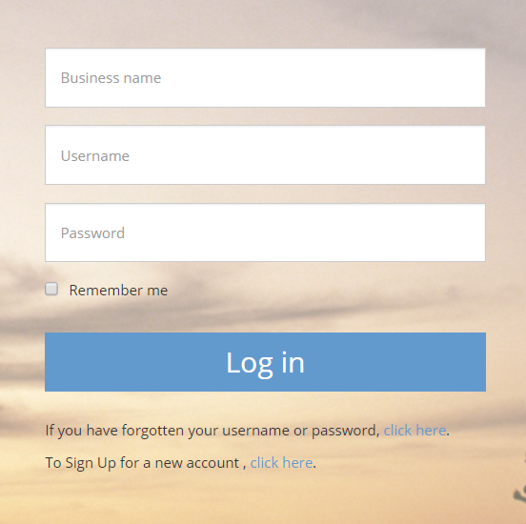

- Click the Login Button

How to Add Membership
- Click the 'Members' tab on the upper left of the screen.

- Click the 'Member Search' on the left pane and find the member.
- Click 'Membership Info' on the left pane.
- Click the 'Add New' button.
- Select a template from the drop down menu if there are templates created and click Next. Otherwise, just click Next-Do Not Use Template.
- Enter the required information. Check 'Auto-Renew' if required.
- Click ‘Save’.
How to Cancel Membership
- Click the ‘Membership Info’ on the left pane of the member’s record.
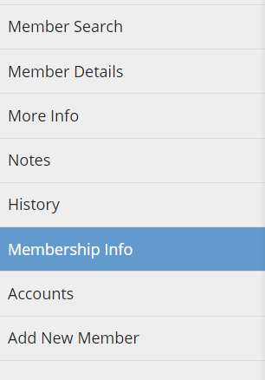
- Click ‘Billing Info’.
- Click the Billing contract you need to be cancelled.
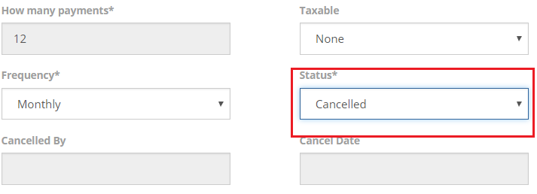
- Set ‘Status’ to Cancelled and click the ‘Save’ button.
- Go back to ‘Membership Info’, select the contract and set ‘Status’ to Cancelled.
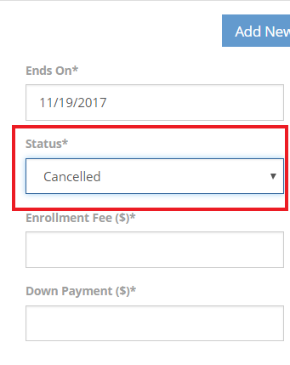

How to Add a Billing Contract
- Click the 'Members' tab on the upper left of the screen.
- Click the 'Member Search' on the left pane and find the member.
- Click 'Membership Info' on the left pane.
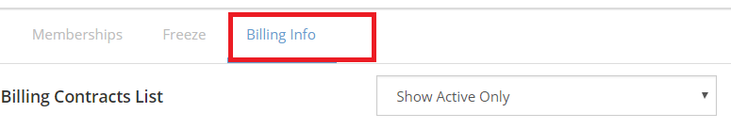
- Click 'Billing Info'
- Select a template from the drop down menu if there are templates created and click Next. Otherwise, just click Next-Do Not Use Template.
- Enter the required information.
- Click Save.
How to Add an Account
- Click the 'Members' tab on on the upper left of the screen.
- Click the 'Member Search' on the left pane and find the member.
- Click 'Accounts' on the left pane.
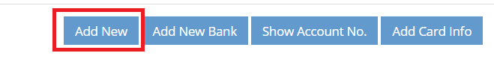
- Click ‘Add New’.
- Enter the required information
- Click ‘Save’
How to Ring Up a Sale
- Under POS tab:
- Find the member
- Select product
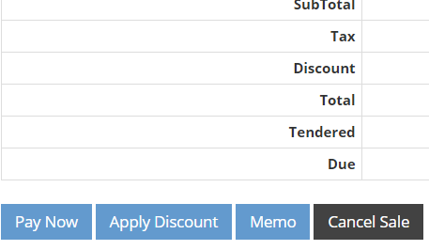
- Click Pay Now and select a payment method.

  - Click ‘Apply Discount’ if you wish to give a discount, click ‘Pay Now’ and select a payment method.
  - Click ‘Memo’ if you wish to create a memo for the sale.
- Complete the transaction.
B. Under Member’s record:
Click POS and continue with number 2-4 steps above.

If Non-member:
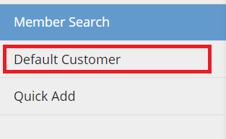
Click ‘Default Customer’ on the left pane and continue with number 2-4 steps above.

You can also use the ‘Quick Add’ button if you want to create a member record with basic information and continue with steps 2-4 above. You can modify the member record later.

How to Do a Refund
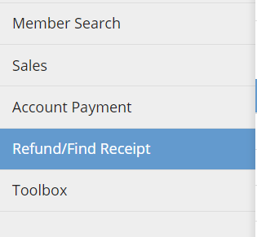
- Under the POS tab, Click the ‘Refund/Find Receipt’ on the left pane.
- Find the transaction and click 'Show Receipt' on the right hand side.
- Click ‘Refund Now’.
- Select a payment method. You will then have the option to email or print the receipt.
- Click ‘Open Drawer’ for cash refund.
- Click ‘Done’ to complete the transaction.

How to create Membership Template.
Note: this can only be done under a username with access to the Setup page.
- Login to QuikChek Cloud
- Click the Setup tab
- Click Membership on the left pane
- Click 'Memberships'
- Click Add New.
- Select Group and enter the membership name.
- Check the 'Active' check box.
- Click the ‘Save’ button

Note: The following steps can only be done under a username with access to the Reports page.

How to Review Billing Reports
- Click the ‘Reports’ tab
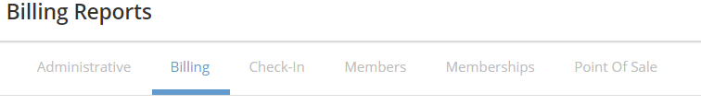
- Click ‘Billing’.
- Click ‘Projected Billing’.
- Enter the date of the billing cycle
- Click Preview to verify list of members and rates are correct.

How to View Daily Check-ins
- Click the ‘Check-in’ tab.
- Click ‘Todays Check-ins’ on the left pane.

How to View the Busy Times at the Club
- Click the ‘Reports’ tab
- Click Checkin under ‘Admin Reports’.
- Click the ‘Hourly Attendance Report’.
- Enter Start and End Dates and select the activities.
- Click ‘Preview’.

How to View Point of Sale Report
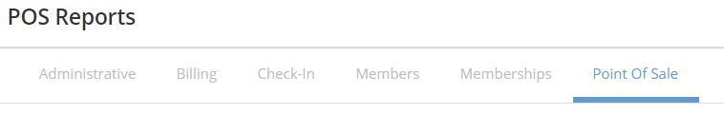
- To view POS Totals, click the ‘Point of Sale’ under Reports.
- Click ‘POS Income’.
- Enter the information required to preview.
- Click ‘Preview’
To view the details of the Pont-of-Sale, Click the POS Details and do steps 3 & 4
How to View the New Members of the Month
- Click the ‘Reports’ tab.
- Click ‘Memberships’.
- New Memberships by Start Date
- Enter the information required to preview.
- Click ‘Preview’.

